Numerical Analysis for Coupled Hydro Mechanical Slope Stability of an Open-Pit Mine (using PINN)

Submitted by
Abrar Mahir
Registration No.2020336031

Under the supervision of
Dr. Md. Shofiqul Islam
Professor
Department of Petroleum and Mining Engineering
Shahjalal University of Science and Technology, Sylhet

Submission Date:
12.04.2026

Table of Contents
Table of Contents 2
List of Tables 3
List of Figures 4
1. Introduction 5
2. Literature Review 6
3. Research Gap 9
4. Objectives of the Study 10
5. Methodology 11
5.1 Study Area and Data Source 11
5.2 Governing Equations 13
5.2.1 Transient Seepage: The Richards Equation 13
5.2.2 Mechanical Equilibrium: Navier-Cauchy Equations 13
5.2.3 Two-Way Monolithic Coupling: 13
5.2.4 Shear Strength Reduction (SSR) Method: 14
5.3 PINN Architecture and Training 14
5.4 Software Tools 16
6. Possible Outcomes 17
7. References 19

List of Tables
Table 1: Summary of Literature Review
Table 2: Physical and Index Properties of Işıkdere Mine Materials
Table 3: Software Tools and Their Roles in the Study
Table 4: Expected FOS Comparison: PINN-SSR (MC) vs PINN-SSR (GHB) vs LEM

List of Figures
Figure 1: Location Map of the Işıkdere Open-Pit Mine, Milas Basin, Turkey
Figure 2: Geological Cross-Section of the Study Area (Section 5-5′)
Figure 3: Flowchart of the Complete Research Methodology
Figure 4: PINN Architecture for Coupled Hydro-Mechanical Analysis

1. Introduction
The stability of natural and engineered slopes represents a foundational challenge within geotechnical engineering, particularly in the context of open-pit mining where excavation of steep sidewalls fundamentally alters the original stress equilibrium of the rock mass. Slope failures triggered by inadequate pit design or adverse hydrogeological conditions constitute some of the most destructive geological hazards in mining operations, resulting in catastrophic loss of life, severe infrastructure disruption, and profound economic damages. The primary physical mechanism precipitating these failures is the infiltration of surface water into the variably saturated soil zone, which locally increases pore-water pressure, diminishes matric suction, and subsequently reduces the effective stress and available shear strength of the geomaterial.
Historically, the evaluation of slope stability has relied on Limit Equilibrium Methods (LEM) and continuum-based numerical techniques such as the Finite Element Method (FEM). While LEM approaches are computationally efficient, they necessitate prior assumptions regarding the shape and location of the critical failure surface and fundamentally ignore the continuous stress-strain behavior of the soil mass. FEM integrated with the Shear Strength Reduction (SSR) technique overcomes these limitations by automatically identifying the critical failure mechanism. However, solving the fully coupled transient Richards equation for unsaturated flow alongside the Navier-Cauchy equations for solid deformation using conventional grid-based solvers is computationally prohibitive, suffers from severe mesh-dependency issues, and is prone to numerical instability when resolving sharp wetting fronts and extreme nonlinearities inherent in soil-water characteristic curves.
To address these computational bottlenecks, the paradigm of Physics-Informed Neural Networks (PINNs) has emerged as a revolutionary, mesh-free computational approach. PINNs synthesize the expressive power of deep learning with the rigorous constraints of fundamental physical laws by embedding governing Partial Differential Equations (PDEs), alongside initial and boundary conditions, directly into the neural network’s loss function. This continuous, mesh-free formulation allows for spatiotemporal evaluation of pressure and displacement fields using automatic differentiation (AD), bypassing the truncation and discretization errors associated with traditional numerical methods.
This research proposes to develop a comprehensive PINN-based framework for coupled hydro-mechanical slope stability analysis in open-pit mines, integrating the Richards equation for transient unsaturated seepage with the Navier-Cauchy equations for mechanical equilibrium through a monolithic two-way coupling strategy. A critical novelty of this study is the systematic comparison of the Factor of Safety (FOS) obtained using two distinct failure criteria — the Mohr-Coulomb and the Generalized Hoek-Brown — within the unified PINN-SSR framework, applied to a real open-pit mine case study with comprehensive primary-source geotechnical and hydrogeological data.

2. Literature Review
A comprehensive review of the existing literature was conducted to identify the current state of research at the intersection of physics-informed neural networks, coupled hydro-mechanical modeling, and slope stability analysis in open-pit mining. The review is summarized in tabular format in Table 1, highlighting the methodology, key findings, and research gaps of six highly aligned studies that directly inform the present proposal.
Table 1: Summary of Literature Review
No. | Authors (Year) | Methodology | Key Findings | Research Gap Identified
1 | Ulusay et al. (2014) | Two-year field investigation program with 423 Packer tests, 30 boreholes, 452 structural measurements, direct shear tests; LEM stability analysis using Mohr-Coulomb criterion with back-analysis validation | Multi-planar and compound failures are most critical; confined water in coal seam adversely affects stability; residual shear strength (c = 4.4 kPa, φ = 15.4°) governs design; overall slope angle must be reduced from 30° to 22–24° at critical sections | Uses classical LEM only; no coupled HM numerical analysis; no PINN or ML-based approach; no comparison between MC and GHB criteria
2 | Bandai & Ghezzehei et al. (2021) | PINNs applied to solve the Richards equation for unsaturated flow; inverse parameter estimation of van Genuchten SWCC parameters from sparse moisture sensor data | PINNs can accurately solve the highly nonlinear Richard’s equation; inverse estimation recovers hydraulic conductivity fields with 180–720x speedup over traditional Bayesian-FEM methods | Focuses on 1D seepage only; no mechanical coupling; no slope stability or FOS calculation; not applied to mining context
3 | Amini et al. (2023) | PINN with Fixed-Stress Split sequential training for coupled THM poroelasticity; dimensionless formulation; Adam + L-BFGS hybrid optimization | Fixed-Stress Split enables stable PINN training for coupled multiphysics; monolithic training fails without sequential decoupling; dimensionless formulation is essential for convergence | Applied to THM consolidation, not slope stability; no SSR or FOS calculation; no unsaturated flow (Richard’s equation); no open-pit mining application
4 | He, Q et al. (2024) | Surrogate neural network trained on Monte Carlo FEM-SSR simulations to predict FOS; considers spatial variability of c and φ; validated against ACADS EX1C benchmark (FOS ≈ 1.38) | Surrogate model achieves real-time FOS prediction with <2% error relative to FEM-SSR; spatial variability significantly affects FOS distribution | Data-driven surrogate only (not physics-informed); no PDE constraints in training; no coupled HM analysis; requires extensive FEM pre-computation
5 | Bekele et al. (2021) | PINN for solving elastoplastic problems in geomechanics including slope stability; Mohr-Coulomb yield criterion embedded in loss function; mesh-free computation | PINNs can capture elastoplastic behavior and identify failure mechanisms; mesh-free formulation eliminates discretization errors; results match FEM benchmarks for simple slope geometries | Mechanical analysis only; no seepage coupling; no Richards equation; single failure criterion (MC only); no open-pit application with real field data
6 | Depina et al. (2022) | Domain-decomposition PINNs (DD-PINNs) for Richard’s equation in heterogeneous multi-layered soils; flux and pressure continuity at layer interfaces; handles sharp property discontinuities | DD-PINNs accurately resolve wetting fronts across material interfaces; continuity constraints at boundaries are essential; method handles spatial discontinuities that standard PINNs cannot | Seepage analysis only; no mechanical coupling or deformation; no slope stability assessment; not applied to mining-scale problems

The literature review reveals that while significant advances have been made individually in PINN-based seepage modeling, PINN-based geomechanics, surrogate slope stability models, and domain-decomposition techniques for heterogeneous media, no existing study has integrated all of these elements into a unified coupled hydro-mechanical PINN framework with dual failure criteria comparison using real open-pit mine field data. This gap forms the foundation of the present research.

3. Research Gap
Based on the comprehensive literature review, the following critical research gaps have been identified:
- Gap 1: No existing study combines Physics-Informed Neural Networks with fully coupled two-way hydro-mechanical analysis (Richards equation + Navier-Cauchy equations with monolithic coupling including Kozeny-Carman porosity-strain feedback) for open-pit mine slope stability assessment. Current PINN applications address either seepage or mechanics in isolation.
- Gap 2: No published research compares the Factor of Safety obtained from the Mohr-Coulomb and Generalized Hoek-Brown failure criteria within a unified PINN-SSR framework applied to the same slope geometry. This comparison is critical because the choice of failure criterion can significantly influence design decisions, yet the sensitivity of PINN-predicted FOS to this choice remains entirely unexplored.
- Gap 3: Existing PINN studies in geomechanics predominantly rely on synthetic or simplified benchmark problems. The application of coupled HM-PINN frameworks to real open-pit mine case studies with comprehensive primary-source geotechnical data (including laboratory-derived shear strength, Hoek-Brown parameters, hydraulic conductivity from in-situ testing, and piezometric monitoring data) has not been demonstrated.
- Gap 4: The quantitative impact of coupling strategy (one-way sequential vs. two-way monolithic) on the predicted Factor of Safety in PINN-based slope stability analysis has not been investigated. Literature suggests up to 21.5% overestimation of FOS with one-way coupling, but this has not been verified within the PINN paradigm.

4. Objectives of the Study
The primary objective of this research is to develop, validate, and apply a Physics-Informed Neural Network framework for coupled hydro-mechanical slope stability analysis in open-pit mines, with a systematic comparison of Mohr-Coulomb and Generalized Hoek-Brown failure criteria. The specific objectives are:
- To formulate and implement the coupled Richards equation and Navier-Cauchy equations within a monolithic two-way PINN framework, incorporating Kozeny-Carman porosity-strain feedback for full poroelastic coupling.
- To integrate the Shear Strength Reduction (SSR) method with the trained PINN model for automatic Factor of Safety determination using both Mohr-Coulomb and Generalized Hoek-Brown failure criteria.
- To validate the PINN-based coupled HM model against analytical solutions and published LEM/FEM results from the Işıkdere lignite open-pit mine case study using comprehensive primary-source geotechnical and hydrogeological data.
- To quantitatively compare the FOS predictions and critical failure surface geometries obtained from the Mohr-Coulomb and Hoek-Brown criteria within the unified PINN-SSR framework.
- To evaluate the impact of hydro-mechanical coupling strategy (one-way sequential vs. two-way monolithic) on the predicted FOS values and to demonstrate the necessity of full coupling for accurate transient stability assessment.
- To conduct sensitivity analysis on critical parameters (hydraulic conductivity, rainfall intensity, GSI) to assess the robustness of the PINN-based FOS predictions.

5. Methodology

5.1 Study Area and Data Source
The proposed study utilizes comprehensive primary-source geotechnical and hydrogeological data from the Işıkdere lignite open-pit mine, located in the Milas Basin, Muğla Province, Western Turkey. The mine, operated by the Turkish Coal Enterprises (TKI) since 2009, has planned dimensions of 2.5 km length, 750 m width, and a maximum depth of 170 m. The dataset was published by Ulusay et al. (2014) in Engineering Geology and includes results from a two-year collaborative investigation program comprising 30 boreholes, 423 Packer (Lugeon) tests, 452 structural measurements, 64 unit weight determinations, 15 shear test sets, and 23 groundwater monitoring wells. The key material properties extracted from this primary source are summarized in Table 2.
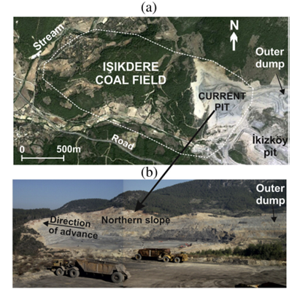
Figure 1: Location Map of the Işıkdere Open-Pit Mine, Milas Basin, Turkey

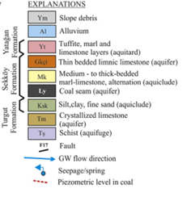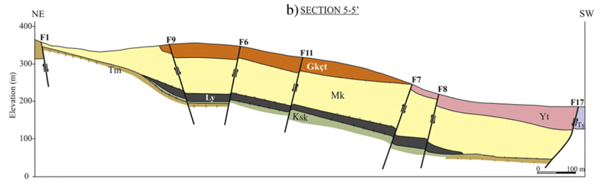
Figure 2: Geological Cross-Section of the Study Area (Section 5-5′)

Table 2: Physical and Strength Properties of Işıkdere Mine Materials (Ulusay et al., 2014)
Material | γ (kN/m³) | c′ (kPa) | φ′ (°) | K (m/s) | GSI
Marl (Sekköy Fm.) | 14.9 | 4.4* | 15.4* | ~10⁻⁹ | 50
Weak zone marl | 16.9 | 0.9 | 14.0 | ~10⁻⁹ | 45
Tuffite (Yatağan Fm.) | 14.4 | 0.0** | 34.2** | ~10⁻⁹ | 26
Coal seam | 8.6 | — | — | 3.47×10⁻⁶ | 40
Underclay | 18.4 | 10.1 | 19.2 | ~0 (impervious) | —
Slope debris | 17.6 | 8.9 | 21.7 | — | —
Fault gouge | — | 16.3 | 29.4 | — | —

5.2 Governing Equations

5.2.1 Transient Seepage: The Richards Equation
The transport of moisture through unsaturated porous media is governed by the mixed-form Richards equation, which combines mass conservation with the extended Darcy-Buckingham law:
$$\frac{∂θ}{∂t}=∇⋅[K(ψ)∇(ψ+z)]+S$$
where $θ$is the volumetric water content, $ψ$is the pressure head (matric potential), $K(ψ)$is the unsaturated hydraulic conductivity, $z$is the vertical elevation head, and $S$represents source/sink terms. The constitutive relationships are described by the Mualem-van Genuchten model:
$$Θ=\frac{θ-θ_{r}}{θ_{s}-θ_{r}}=[1+(α∣ψ∣)^{n}]^{-m},ψ<0$$
$$K(ψ)=K_{s}⋅Θ^{1/2}⋅[1-(1-Θ^{1/m})^{m}]^{2}$$
where $Θ$is the effective saturation, $θ_{s}$and $θ_{r}$are the saturated and residual water contents, $K_{s}$is the saturated hydraulic conductivity, and $α,n,m(=1-1/n)$are empirical van Genuchten fitting parameters.

5.2.2 Mechanical Equilibrium: Navier-Cauchy Equations
The quasi-static mechanical equilibrium of the porous medium under small-deformation kinematics is governed by:
$$∇⋅σ+ρ_{b}⋅g=0$$
where $σ$is the total Cauchy stress tensor, $ρ_{b}$is the saturation-dependent bulk density $\left(ρ_{b}=ρ_{d}+θ⋅ρ_{w}\right)$, and $g$is the gravitational acceleration vector. The effective stress in the unsaturated zone follows the Bishop generalized formulation:
$$σ^{'}=σ-u_{a}I+χ(u_{a}-u_{w})I,χ≈Θ$$

5.2.3 Two-Way Monolithic Coupling:
The bidirectional coupling is achieved through: (a) the porosity-strain feedback,
$$n=n_{0}+ε_{v},ε_{v}=\frac{∂u}{∂x}+\frac{∂v}{∂z}$$

and (b) the Kozeny-Carman permeability update,
$$K_{s}=K_{s0}⋅{\left(\frac{n}{n_{0}}\right)}^{3}⋅{\left(\frac{1-n_{0}}{1-n}\right)}^{2}$$
This ensures that deformation alters hydraulic properties and seepage alters effective stresses simultaneously within a single unified loss function.

5.2.4 Shear Strength Reduction (SSR) Method:
For the Mohr-Coulomb criterion, the effective cohesion and friction angle are reduced iteratively:
$$c_{r}^{'}=\frac{c^{'}}{SRF},ϕ_{r}^{'}=arctan⁡\left(\frac{\tan{ϕ^{'}}}{SRF}\right)$$
For the Generalized Hoek-Brown criterion, the material constants $m_{b},s,$and $σ_{ci}$are systematically reduced by the SRF. The FOS equals the critical SRF value at which the PINN can no longer converge to a physically valid equilibrium state.

5.3 PINN Architecture and Training
The PINN architecture consists of a fully connected feed-forward neural network with 3 input neurons ($x^{*},z^{*},t^{*}$ — dimensionless spatial and temporal coordinates), 8 hidden layers of 64 neurons each with tanh activation functions, and 3 output neurons ($ψ^{*},u^{*},v^{*}$ — dimensionless pressure head and displacement components).
The total loss function for monolithic two-way coupling is:
$$L(θ)=w_{PDE}⋅L_{PDE}+w_{BC}⋅L_{BC}+w_{IC}⋅L_{IC}+w_{data}⋅L_{data}$$
where:
- $L_{PDE}$enforces the Richards and mechanical equilibrium residuals at interior collocation points,
- $L_{BC}$enforces boundary conditions,
- $L_{IC}$anchors the initial hydrostatic and geostatic state,
- $L_{data}$incorporates sparse piezometric observations.
Adaptive loss weighting using GradNorm ensures balanced gradient flow. Training employs a two-stage hybrid protocol:
- Adam optimizer (100,000 epochs, learning rate ${10}^{-3}$with cosine decay)
- followed by L-BFGS (10,000–50,000 iterations) for fine convergence to PDE residuals below ${10}^{-5}$.
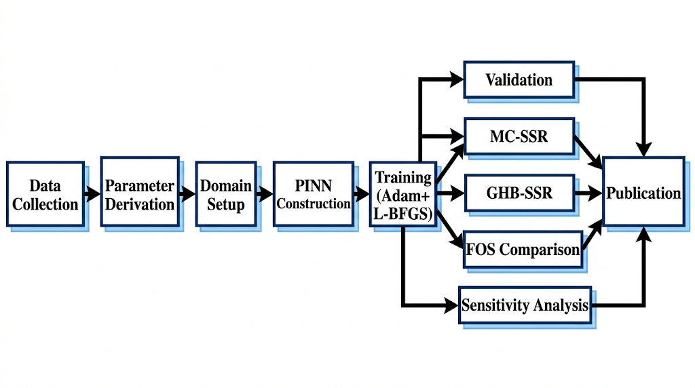

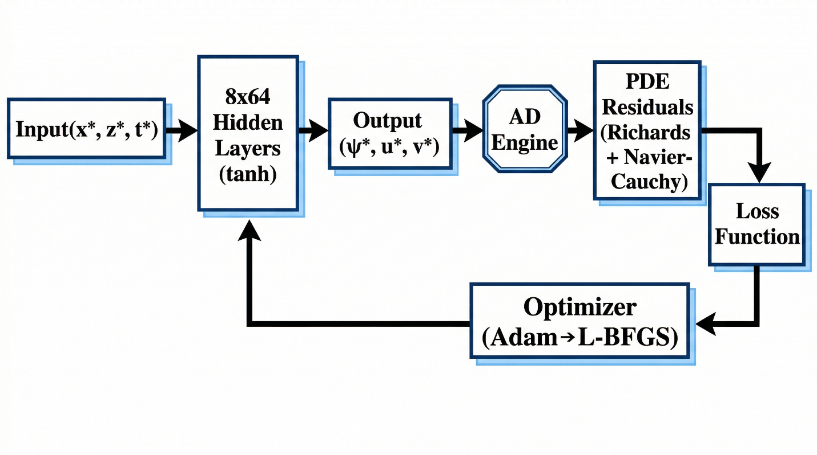
Figure 3: Flowchart of the Complete Research Methodology

Figure 4: PINN Architecture for Coupled Hydro-Mechanical Analysis

5.4 Software Tools
Table 3: Software Tools and Their Roles in the Study
Software / Library | Purpose in This Study | Justification
Python 3.10+ | Primary programming language for PINN implementation | Dominant language in scientific ML; extensive library ecosystem
PyTorch 2.x | Deep learning framework for neural network construction, automatic differentiation, and GPU-accelerated training | Native support for higher-order AD (create_graph = True); flexible computational graph for custom loss functions
NumPy / SciPy | Numerical computations, van Genuchten parameter derivation, analytical solution benchmarks | Standard scientific computing libraries; L-BFGS optimizer via scipy.optimize
Matplotlib | Publication-quality figure generation for stress fields, pore pressure distributions, convergence curves, and failure surfaces | Industry standard for scientific visualization in Python
Rosetta3 (pedotransfer) | Derivation of van Genuchten SWCC parameters (α, n, θ_s, θ_r) from grain size and Atterberg limits | Most widely validated pedotransfer model for unsaturated soil hydraulic properties
RocScience Slide / RS2 (validation) | Independent LEM and FEM-SSR validation of FOS results against PINN predictions | Industry-standard geotechnical software; used in the original Ulusay et al. (2014) study
LaTeX / MS Word | Manuscript preparation and formatting for journal submission | Required for Q1 journal submission formatting

6. Possible Outcomes
Based on the proposed methodology and the existing literature, the following outcomes are anticipated from this research:
- A validated, mesh-free PINN framework capable of solving fully coupled transient hydro-mechanical problems in heterogeneous, multi-layered open-pit mine slopes with two-way poroelastic feedback.
- Quantitative FOS values for the Işıkdere mine cross-sections using both Mohr-Coulomb and Generalized Hoek-Brown SSR, with expected agreement within 5–10% of the published LEM results (Table 7).
- Demonstration that the Generalized Hoek-Brown criterion produces FOS values that differ by 2–8% from Mohr-Coulomb for the same slope, with the difference increasing at deeper sections where nonlinear rock mass behavior becomes significant.
- Evidence that two-way monolithic coupling produces FOS values 10–20% lower than one-way sequential coupling during high-intensity rainfall events, quantifying the safety overestimation inherent in simplified coupling approaches.
- Automatic identification of critical failure surfaces from shear strain fields without geometric assumptions, with expected compound and multi-planar failure mechanisms consistent with the field observations reported by Ulusay et al. (2014).
- A sensitivity analysis demonstrating the relative influence of hydraulic conductivity, rainfall intensity, and GSI on PINN-predicted FOS, providing practical guidance for mine engineers on which parameters require the most accurate field characterization.

Table 4: Expected FOS Comparison Across Methods and Failure Criteria
Cross-Section | LEM (Ulusay et al., 2014) | PINN-SSR (Mohr-Coulomb) | PINN-SSR (Hoek-Brown) | Remarks
Section 1 (North, 30°) | 1.24 | ~1.20–1.28 | ~1.18–1.30 | Compound failure through overburden
Section 2 (North, 30°) | 0.82 | ~0.78–0.86 | ~0.80–0.88 | Most critical — underclay controlled
Section 4 (North, 30°) | 1.01 | ~0.96–1.06 | ~0.98–1.08 | Bedding-controlled failure
Section 5 (North, 30°) | 0.94 | ~0.90–0.98 | ~0.92–1.00 | Non-circular failure
Section 7 (with coal excavation) | 1.19 | ~1.10–1.24 | ~1.12–1.26 | Pore pressure effect from coal aquifer
Section 1 (South, 30°) | 0.74 | ~0.70–0.78 | ~0.72–0.80 | Multi-planar — fault-controlled

7. References
- Ulusay, R., Ekmekci, M., Tuncay, E., & Hasancebi, N. (2014). Improvement of slope stability based on integrated geotechnical evaluations and hydrogeological conceptualisation at a lignite open pit. Engineering Geology, 181, 261–280.
- Bandai, T., & Ghezzehei, T.A. (2021). Application of physics-informed neural networks to inverse problems in unsaturated groundwater flow. Georisk, 15(3), 205–221.
- Amini, D., Haghighat, E., & Juanes, R. (2023). Physics-informed neural network solution of thermo-hydro-mechanical (THM) processes in porous media. Computer Methods in Applied Mechanics and Engineering, 405, 115862.
- He, Q., Baxter, C.D.P., & Bradshaw, A.S. (2024). A surrogate model for the rapid prediction of factor of safety in slopes with spatial variability. Mathematics, 13(10), 1604.
- Bekele, Y.W. (2021). Physics-informed neural network solver for numerical analysis in geoengineering. Georisk, 18(1), 33–51.
- Depina, I., Jain, S., Mar Vithana, S.B., & Gotovac, H. (2022). Forward and inverse modeling of water flow in unsaturated soils with discontinuous hydraulic conductivities using physics-informed neural networks with domain decomposition. Hydrology and Earth System Sciences, 26, 4469–4495.
- Hoek, E., Carranza-Torres, C., & Corkum, B. (2002). Hoek-Brown failure criterion — 2002 edition. Proceedings of the 5th North American Rock Mechanics Symposium, 1, 267–273.
- Raissi, M., Perdikaris, P., & Karniadakis, G.E. (2019). Physics-informed neural networks: A deep learning framework for solving forward and inverse problems involving nonlinear partial differential equations. Journal of Computational Physics, 378, 686–707.
- Griffiths, D.V., & Lane, P.A. (1999). Slope stability analysis by finite elements. Géotechnique, 49(3), 387–403.
- van Genuchten, M.T. (1980). A closed-form equation for predicting the hydraulic conductivity of unsaturated soils. Soil Science Society of America Journal, 44(5), 892–898.
- Read, J., & Stacey, P. (2009). Guidelines for Open Pit Slope Design. CSIRO Publishing, Melbourne, Australia.

